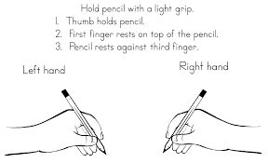

Hathern C of E Primary School

*‘Learning and Caring Together’*

**Physical Development:**

**Fine motor skills:**

* Holding a pencil correctly
* Threading beads onto string
* Tweezers to grab and move

**Gross motor skills:**

* Travelling in different ways – walking, running, hopping
* Manipulating dough - rolling, squeezing, pinching

**Weekly tasks:**

**Show & Tell**  A chance to talk about ourselves and our families.

**PE** Learning about how to move, control and stretch our bodies.

**Yoga** Time to relax

and unwind.

**‘Marvellous Me’**

**Autumn Term 1**

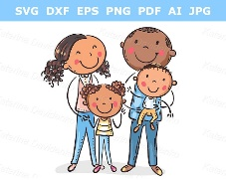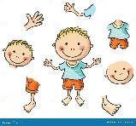



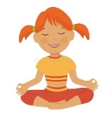



**Daily tasks:**

* Phonics lesson

(weekly updates will be sent home)

* Maths lesson

(starting with counting, comparing, number sequencing and 2D shapes)

* English / topic lesson

(engaging core texts are used to engage, enthuse and teach our topics)

**Religious Education:**

* Daily collective worship
* Weekly RE lessons
* Integrated CARE code

**PSHE:**

* Caring for ourselves & others
* Our friends and families
* Classroom rules & routines

**We will learn to:**

* Name our five senses
* Name our body parts
* Describe how we move and grow
* Create pictures of ourselves in different ways
* Balance, hop and run
* Understand where we live and what is around us

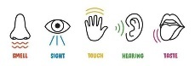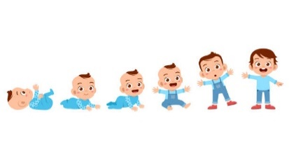



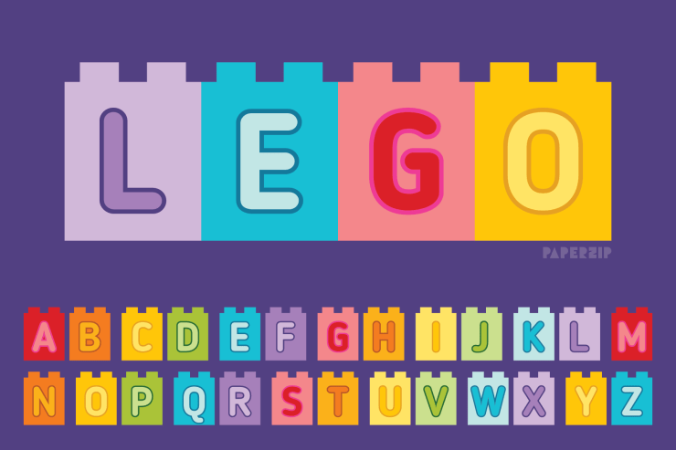

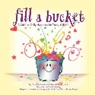



Key Vocabulary: body, head, shoulder, arm, leg, knee, hip, toes, fingers, feet, hands, neck, nose, eyes, ears, tongue, back, stomach, sense, smell, sight, touch, hearing, smelling, family, Dad, Mum, Sister, Brother, Auntie, Uncle, Grandma, Grandad, cousin