Year Three Good Friday Experiment
This is a fun experiment to demonstrate that when Jesus died He took away the sins of the world. You will need the help of an adult

First, here are the things you need.

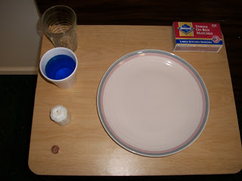

A plate or saucer, a coin, a candle, matches, cup of coloured water (any colour can be used), and a clear drinking glass. Tell the kids that you are going to explain what happened at the cross.

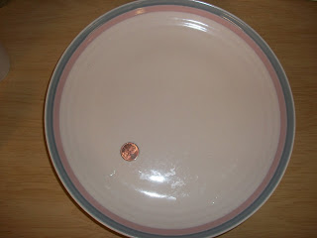
Hold the penny up and tell the kids that the penny represents us. Place the penny on the plate toward the side. Now take the coloured water which represents sin.

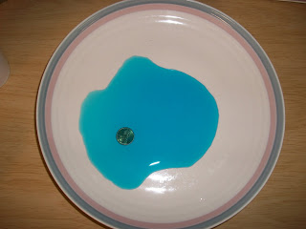

Pour the coloured water over the coin until it is submerged, just as in life we are covered with sin. Experiment with the water to see how much to put on the plate for the experiment to work right. Next take the white candle that represents Jesus and put it in the middle of the plate.

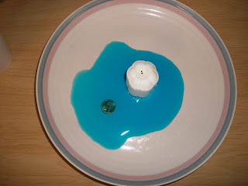

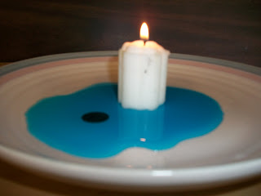

Light the candle, the flame represents the life of Christ. Tell the children to watch carefully as you take the glass and put it over the lighted candle.

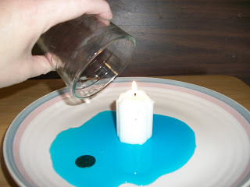

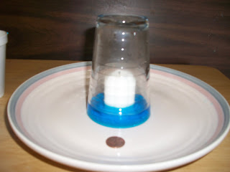

Within a few seconds, the flame will consume all the oxygen in the glass and be extinguished. However, it will have created a vacuum which, in turn will draw the water up inside the glass (thus surrounding the candle) and leave the coin dry. Tell the children that on the cross Jesus gave up his life (the flame went out) so that he could take our sins on Himself and we could be free.

